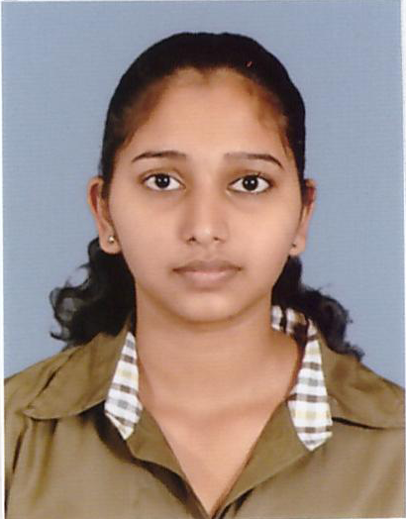
Miss.Prabashini Rebecca Senthilnathan

No.166 /66, Banadara nayaka Mawatha.Co-12
Tel: 0094 75 2089638
Email: prabashinirebecca@gmail.com

Profile
I am an Energetic, quick learner ambitious person who has developed a mature and responsible approach to any task that I undertake, or situation I am presented with. I am excellent in working with others to achieve a certain objective on time with and with excellence. And I am Interested in working as team. I just complete my G.C.E (A/L) last year and got through with good results. I worked as Trainee Secretary in Leopard Motor Co (Pvt) Ltd.Colombo for six months & I am continuing my higher studies in Infortec International, Nugegoda. By following HDCS (higher diploma in computer science). I had complete diploma in Ms- office & diploma in graphic designing courses In V-Tech Institute, Kotahena. and complete certificate course in spoken English & grammar in Unique Institute. I hope to study BCS (British computer society) degree after complete the higher diploma which I am following now. I am interested in IT field , My ambition is to be a software engineer in future;
As well as I can handle & I am Interested to get experience in various kind of job roles.

Work experience
I have join as trainee secretary and also I have trained to achieve various job roles. Such as
- Taking Minutes on Meetings.
- Handling Legal documents of the company
- Preparing necessary documents for obtain visa for company directors
- Quotations Analyzing and coordinating company purchases
- Preparing and handling logistics documents for company stocks Transfers.
- Attending customer calls & giving instructions to the customers about the product.
- Coordinate Advertisements and Web side.

Computer Skills
Diploma in Ms Office & Diploma in Graphic designing Institution: V-Tech Institute. 2012-2013
- Introduction to Computer.
- Ms-Word, Ms-Excel, Ms-Power point, Ms-Access
- Introduction to Internet & e-mail.
- Adobe photoshop CS-6, Corel draw X6

Language Skills

- Having good command in English, Sinhala & Tamil (Read/Write)

Extra Curricular Activities

- President of Commerce Union in year of 2013 in C/Good shepherd G.M.V.
- Senior Prefect in year of 2013-2014
- Office bearer of Leo Club of Shepherdians
- Committee member of Senior Debate Team in C/Good Shepherd G,M.V

Educational Qualification

Good Shepherd Girls’ M.V. Colombo-13. ( 2001-2014)

Passed (G.C.E) Advance Level – 2014 in Commerce Stream.
- Economics : A
- Accounting : C
- Business Studies : C
- General English : C
- General Knowledge : 57 Marks
- General Information Technology : A
- (Exam in 2013)

Passed (G.C.E) Ordinary Level -2011
- Mathematics : A
- English : A
- Tamil language : B
- Religion (R.C) : B
- ICT : C
- Commerce : C
- History : C
- Science : C
- Art : C

Personal Details
- Date of Birth : July 11th in 1995
- Nationality : Sri Lankan
- Religion : Christian
- Civil Status : Single
- Gender : Female
- NIC No. : 956932203 V

None related References

- P.J.Sithambaram, ADCIMA UK, MBA UK
Finance & Admin Manager
Leopard Motor Co (Pvt) Ltd.
0094 77 0070401
Jerad.leopard2013@gmail.com

- M.Satheswaran, MMEngnr,SLII.
Director VTechnology
0094 77 5719294

I do hereby declare that the particulars furnished by me above are true and correct to the best of my knowledge.

Sign:--S.Prabashini------ Date :-----------------
.

